Bank.java

public interface Bank extends java.rmi.Remote
{
public String c_name(String name) throws java.rmi.RemoteException;
public long account_no(long acc_no) throws java.rmi.RemoteException;
public long balance(long amount) throws java.rmi.RemoteException;
public long view(int amount)throws java.rmi.RemoteException;
public long deposit(int amount)throws java.rmi.RemoteException;
public long withdraw(int amount) throws java.rmi.RemoteException;
}

BankImpl.java

public class BankImpl extends java.rmi.server.UnicastRemoteObject implements Bank
{
public BankImpl() throws java.rmi.RemoteException
{
super();
}
public long view(int amount) throws java.rmi.RemoteException
{
System.out.println("\n\t\t\tCustomer Detail");
return amount;
}
public long deposit(int amount)throws java.rmi.RemoteException
{
System.out.println("\n\t\t\tAmount deposited");
return amount;
}
public long withdraw(int amount) throws java.rmi.RemoteException
{
System.out.println("\n\t\t\tAmount Withdrawn");
return amount;
}
public String c_name(String name) throws java.rmi.RemoteException
{
System.out.println("\nThe name of the customer is:" + name);
return name;
}

public long account_no(long acc_no) throws java.rmi.RemoteException
{
System.out.println("\nThe Account Number is:" + acc_no);
return acc_no;
}
public long balance(long amount) throws java.rmi.RemoteException
{

System.out.println("\nThe Current Balance is:" + amount);
return amount;
}
}

BankServer.java

import java.rmi.Naming;
public class BankServer
{
public BankServer()
{
try
{
Bank c = new BankImpl();
Naming.rebind("rmi://localhost:1099/BankService", c);
}
catch (Exception e)
{
System.out.println("Trouble: " + e);
}
}
public static void main(String args[])
{
new BankServer();
}
}

BankClient.java

import java.io.*;
import java.rmi.Naming;
import java.rmi.RemoteException;
import java.net.MalformedURLException;
import java.rmi.NotBoundException;
public class BankClient
{
public static void main(String[] args)
{
String name="default",namelist[]={"vinodh","parthi","karthi", "mei","bala","kasi"};
int acc_no=0,acc_nolist[]={1,2,3,4,5,6},amount=0,newamount[]={0,0,0,0,0,0},
amountlist[]={0,0,0,0,0,0},new_amount, option,sub_option,con=0,i,count=1;
DataInputStream in=new DataInputStream(System.in);
try
{
do
{
Bank c = (Bank)Naming.lookup("rmi: //localhost/BankService");
if (count == 1)
{
System.out.println("Enter the Account no:");
acc_no = Integer.parseInt(in.readLine());
count = 0;
if (acc_no == 1)
{
name = namelist[0];
acc_no = acc_nolist[0];
amount = amountlist[0] + newamount[0];
}
else if (acc_no == 2)
{
name = namelist[1];
acc_no = acc_nolist[1];
amount = amountlist[1]+newamount[1];
}
else if (acc_no == 3)
{
name = namelist[2];
acc_no = acc_nolist[2];
amount = amountlist[2]+newamount[2];
}
else if (acc_no == 4)
{
name = namelist[3];
acc_no = acc_nolist[3];
amount = amountlist[3]+newamount[3];
}
else if (acc_no == 5)
{
name = namelist[4];
acc_no = acc_nolist[4];
amount = amountlist[4]+newamount[4];
}
else if (acc_no == 6)
{
name = namelist[5];
acc_no = acc_nolist[5];
amount = amountlist[5]+newamount[5];
}
else
{
System.out.println("Your entered account number is wrong:");
}
}
System.out.println("\nMenu list:");
System.out.print("\n\t1. To change the account no\n\n\t2. View Statement\n\n\t3. Deposit Money\n\n\t4. Withdraw Money");
System.out.print("\n\nEnter your Input as 1 or 2 or 3 or 4 only:");
option = Integer.parseInt(in.readLine());
switch (option)
{
case 1:
{
if (acc_no == 1)
{
newamount[0] = amount;
}
else if (acc_no == 2)
{
newamount[1]=amount;
}
else if (acc_no == 3)
{
newamount[2]=amount;
}
else if (acc_no == 4)
{
newamount[3]=amount;
}
else if (acc_no == 5)
{
newamount[4]=amount;
}
else if (acc_no == 6)
{
newamount[5]=amount;
}
count = 1;
break;
}
case 2:
{
c.view(amount);
c.c_name(name);
c.account_no(acc_no);
c.balance(amount);
break;
}
case 3:
{
System.out.print("\nEnter the amount to be deposited:");
new_amount = Integer.parseInt(in.readLine());
c.deposit(amount);
System.out.println("\nYour amount has been deposited successfully");
amount=amount+new_amount;
c.c_name(name);
c.account_no(acc_no);
c.balance(amount);
break;
}
case 4:
{
System.out.print("\nEnter the amount to be Withdrawn:");
new_amount = Integer.parseInt(in. readLine());
if(new_amount<=amount)
{
System.out.println("\nYour amount has been withdrawn successfully");
amount=amount-new_amount;
c.withdraw(amount);
c.c_name(name);
c.account_no(acc_no);
c.balance(amount);
}
else
{
System.out.println("\nInsufficient balance to withdrawn that amount from your account");
}
break;
}
default:
{
System.out.println("Your entered option is wrong:");
break;
}
}
System.out.print("\n\nTo go back to main menu then press 1:");
con = Integer.parseInt(in.readLine());
}
while (con== 1);
}
catch (Exception e)
{
System.out.println("Error");
}
}
}

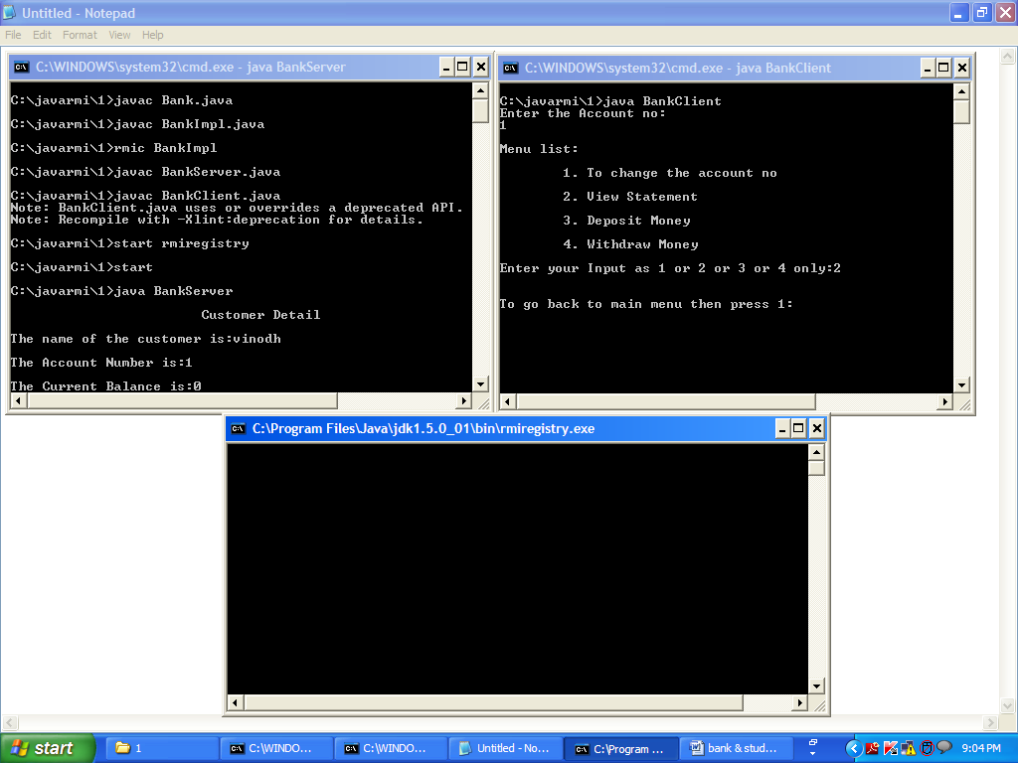

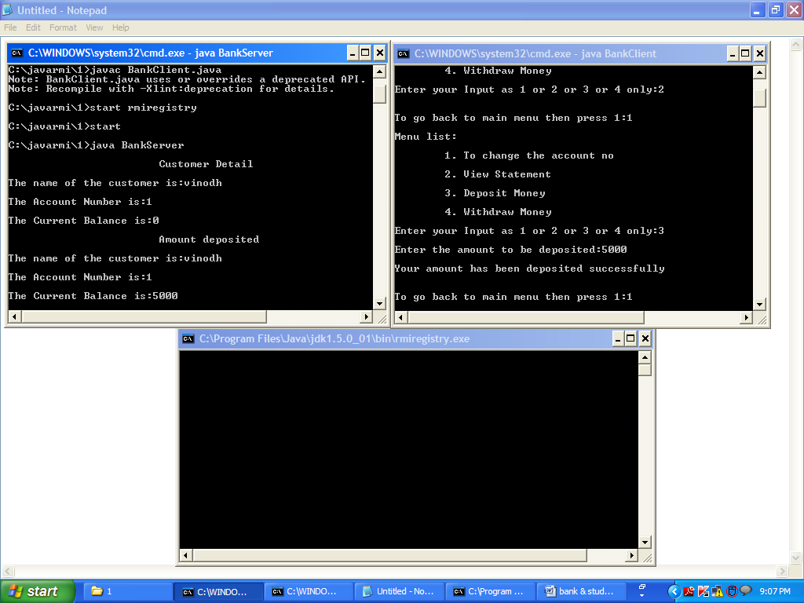
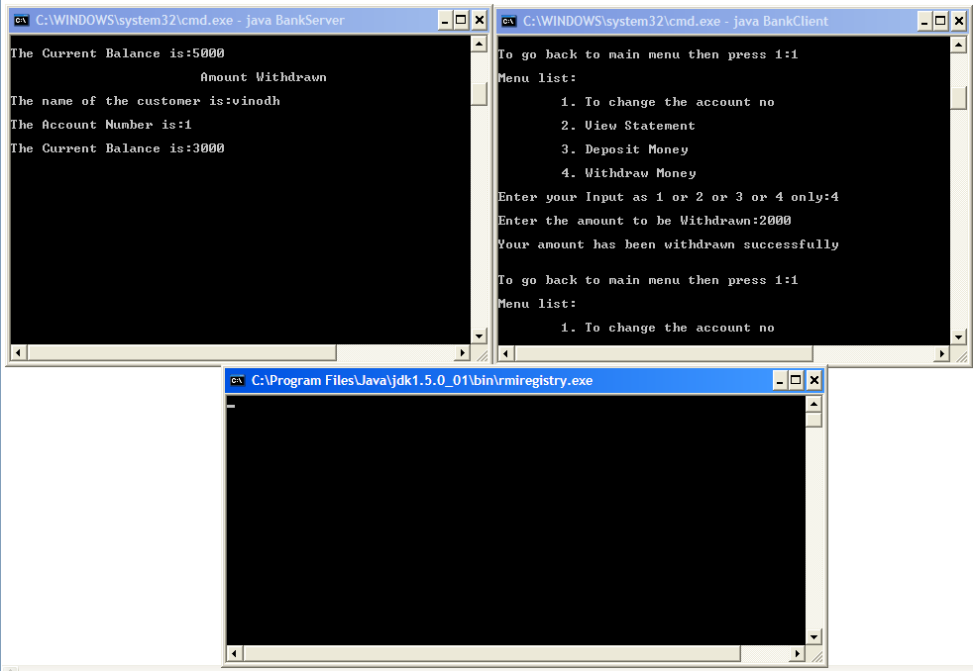
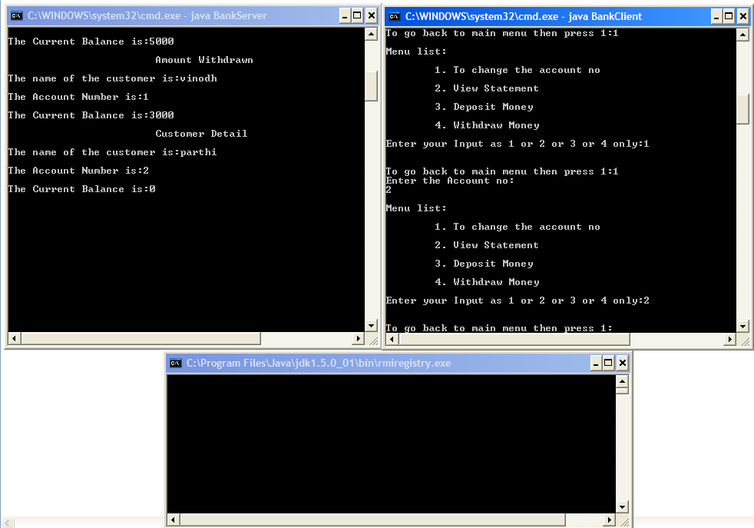
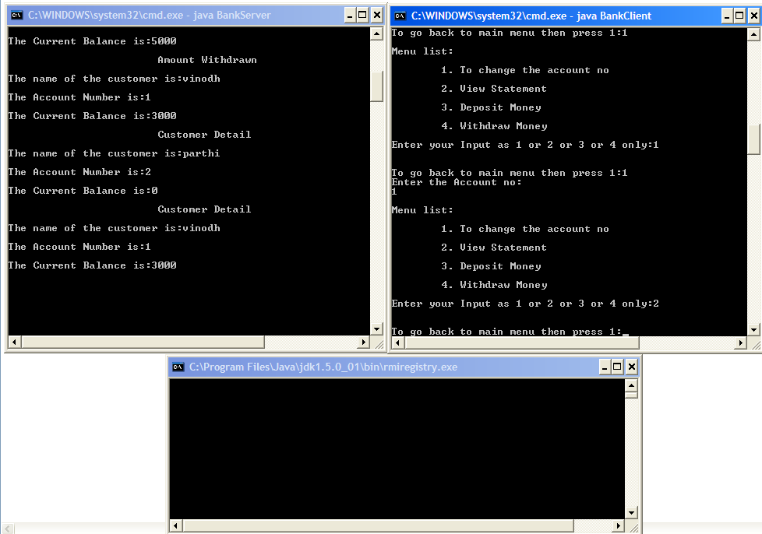

Student.java

public interface Student extends java.rmi.Remote
{
public String s_name(String name) throws java.rmi.RemoteException;
public long reg_no(long reg_no) throws java.rmi.RemoteException;
public long marks(long m1, long m2, long m3) throws java.rmi.RemoteException;
public long total(long tot)throws java.rmi.RemoteException;
public long average(long average)throws java.rmi.RemoteException;
}

StudentImpl.java

public class StudentImpl extends java.rmi.server.UnicastRemoteObject implements Student
{
public StudentImpl() throws java.rmi.RemoteException
{
super();
}
public String s_name(String name) throws java.rmi.RemoteException
{
System.out.println("\t\t\tStudent Detail");
System.out.println("\nName:" + name);
return name;
}
public long reg_no(long reg_no) throws java.rmi.RemoteException
{
System.out.println("\nReg.NO:" + reg_no);
return reg_no;
}
public long marks(long m1,long m2,long m3) throws java.rmi.RemoteException
{

System.out.println("\nMark1:" +m1);
System.out.println("\nMark2:" +m2);
System.out.println("\nMark3:" +m3);
return (m1+m2+m3);
}
public long total(long total) throws java.rmi.RemoteException
{
System.out.println("\nThe total of 3 marks is:"+total);
return total;
}
public long average(long average)throws java.rmi.RemoteException
{
System.out.println("\nThe average of 3 marks is:"+average);
return average;
}
}

StudentServer.java

import java.rmi.Naming;
public class StudentServer
{
public StudentServer()
{
try
{
Student s = new StudentImpl();
Naming.rebind("rmi://localhost:1099/BankService", s);
}
catch (Exception e)
{
System.out.println("Trouble: " + e);
}
}
public static void main(String args[])
{
new StudentServer();
}
}

StudentClient.java

import java.io.*;
import java.rmi.Naming;
import java.rmi.RemoteException;
import java.net.MalformedURLException;
import java.rmi.NotBoundException;
public class StudentClient
{
public static void main(String[] args)
{
String name="default",namelist{"raju","ramu","dilip","siva","rajiv","anbu"}; int reg_no = 0, reg_nolist[] ={ 1, 2, 3, 4, 5, 6 };
int m1list[] ={ 50, 60, 50, 60, 50, 60 }, m2list[] ={ 50, 60, 50, 60, 50, 60 },m1=0,m2=0, m3=0;
int m3list[] ={ 50, 60, 50, 60, 50, 60}, option, sub_option, con = 0, i, count = 1,total=0, average=0;
DataInputStream in=new DataInputStream(System.in);
try
{
do
{
Student s = (Student)Naming.lookup("rmi://localhost/BankService");
if (count == 1)
{
System.out.println("Enter the Register no:");
reg_no = Integer.parseInt(in.readLine());
count = 0;
if (reg_no == 1)
{
name = namelist[0];
reg_no = reg_nolist[0];
m1 = m1list[0];
m2 = m2list[0];
m3 = m3list[0];
}
else if (reg_no == 2)
{
name = namelist[1];
reg_no = reg_nolist[1];
m1 = m1list[1];
m2 = m2list[1];
m3 = m3list[1];
}
else if (reg_no == 3)
{
name = namelist[2];
reg_no = reg_nolist[2];
m1 = m1list[2];
m2 = m2list[2];
m3 = m3list[2];
}
else if (reg_no == 4)
{
name = namelist[3];
reg_no = reg_nolist[3];
m1 = m1list[3];
m2 = m2list[3];
m3 = m3list[3];
}
else if (reg_no == 5)
{
name = namelist[4];
reg_no = reg_nolist[4];
m1 = m1list[4];
m2 = m2list[4];
m3 = m3list[4];
}
else if (reg_no == 6)
{
name = namelist[5];
reg_no = reg_nolist[5];
m1 = m1list[5];
m2 = m2list[5];
m3 = m3list[5];
}
else
{
System.out.println("Your entered register number is wrong:");
}
}
System.out.println("\nMenu list:");
System.out.print("\n\t1. To change the register no\n\n\t2. View Details\n\n\t3. Total\n\n\t4. Average");
System.out.print("\n\nEnter your Input as 1 or 2 or 3 or 4 only:");
option = Integer.parseInt(in.readLine());
switch (option)
{
case 1:
{
count = 1;
break;
}
case 2:
{
s.s_name(name);
s.reg_no(reg_no);
s.marks(m1,m2,m3);
break;
}
case 3:
{
System.out.print("\nThe Total of Three Marks is:");
total = m1 + m2 + m3;
System.out.print("" + total);
s.total(total);
break;
}
case 4:
{
System.out.print("\nThe average of Three Marks is:");
average = total / 3;
System.out.print("" + average);
s.average(average);
break;
}
default:
{
System.out.println("Your entered option is wrong:");
break;
}
}
System.out.print("\n\nTo go back to main menu then press 1:");
con = Integer.parseInt(in.readLine());
}
while (con== 1);
}
catch (Exception e)
{
System.out.println("Error");
}
}
}

